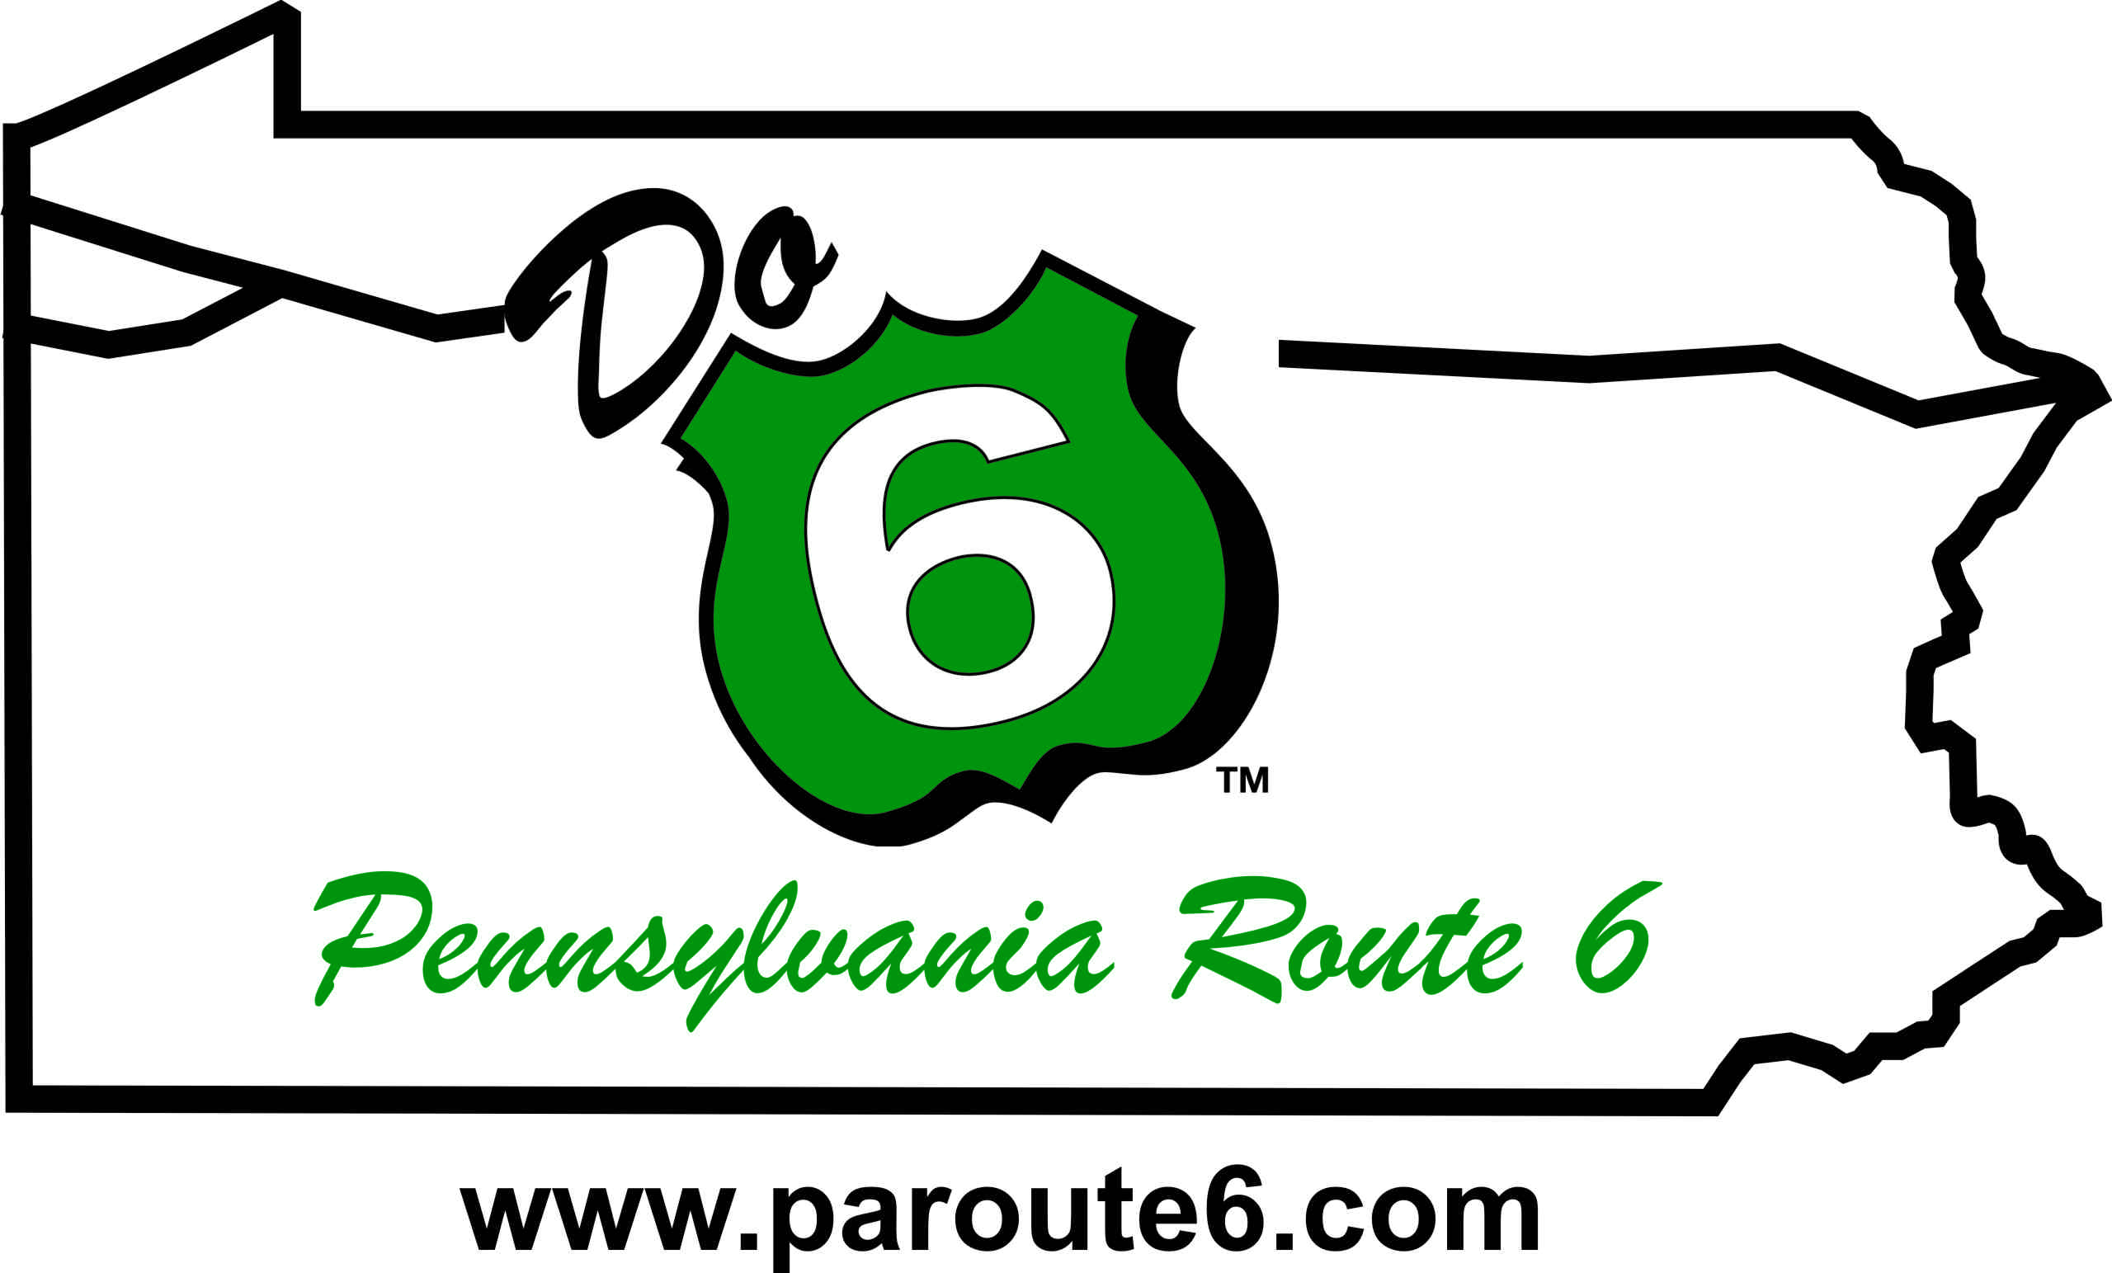**FOR IMMEDIATE RELEASE:**

April 15, 2024

**PA Route 6 Alliance**

814-435-7706

[info@paroute6.com](mailto:info@paroute6.com)

**PA Route 6 Alliance Accepting Nominations for 2024 “Do 6” Awards**

*Recognizing outstanding persons, groups, and communities along PA Route 6!*

The PA Route 6 Alliance is requesting nominations for their 14th annual “Do 6” Awards recognizing individuals, groups, projects and communities that exemplify and advance the Alliance’s mission of protecting, preserving and promoting the scenic, cultural, historic and recreational resources across the 11-county corridor of PA Route 6.

Nominations may be submitted until June 15, 2024, by any individual or group through the online or printable form at [www.paroute6.com/annual-do-6-awards](http://www.paroute6.com/annual-do-6-awards). Award winners will be notified upon selection and awards will be presented at the PA Route 6 Annual Meeting and “Do 6” Awards Program on September 20th in Honesdale, PA.

Currently, nominations can be made in six categories:

**LIFETIME ACHIEVEMENT AWARD** - Presented to a person or agency who exemplifies outstanding leadership and advances our mission through heritage development.

**HERITAGE PARTNERSHIP AWARD** - Presented to a group, person or organization that has demonstrated excellence in historic preservation, cultural preservation, interpretation, and/or education through cross-corridor thinking and interagency cooperation.

**HERITAGE TOURISM AWARD** - Presented to a business or project that furthers economic and tourism development while respecting the heritage and cultural resources of the PA Route 6 Corridor.

**ARTISAN OF THE YEAR AWARD** - Presented to an artist or artisan group that exemplifies the goals of the PA Route 6 Artisan Trail program showing regional thinking and cooperation while promoting the arts along the corridor.

**HERITAGE LEADERSHIP AWARD** - Presented to a person(s), business or organization for meaningful contributions and/or through partnerships, by enriching our communities through landscape initiatives or historic preservation.

**HERITAGE COMMUNITY OF THE YEAR** - Presented to the designated Heritage Community, who are embracing their Heritage Tourism Work Plans and implementing worthwhile projects and showing impacts and results.

2023 award winners included Hurry Hill Farm and Museum Association in Edinboro (*Heritage Partnership*); Elliot Ness Museum in Coudersport (*Heritage Tourism*); Allegheny National Forest Visitors Bureau in Bradford (*Heritage Leadership*); Honesdale Partnership in Honesdale, PA (*Heritage Community of the Year*); The Gathering Place in Clarks Summit (*Artisan of the Year*); and Melinda Meyer of Preservation Erie (*Lifetime Achievement*).

For more information on the “Do 6” Awards Program and the 2024 PA Route 6 Educational Workshop & Annual Meeting, visit [www.paroute6.com/2024-annual-meeting](http://www.paroute6.com/2024-annual-meeting) or contact the Alliance at [info@paroute6.com](mailto:info@paroute6.com) or 814-435-7706.

*The PA Route 6 Alliance, a 501(c3) corporation, was established in 2003 to manage the PA Route 6 Heritage Corridor and to implement branding and marketing plans, community development programs and other planning efforts along the corridor. The Alliance includes representatives from all 11 counties, 9 convention and visitor bureaus, 4 heritage areas, local development districts, local business owners, Chambers of Commerce, and other interested parties along the corridor. The PA Route 6 Heritage Communities program is a program of PA Route 6 Alliance and PA Route 6 Heritage Corridor funded by the PA Heritage Area Program under the Pennsylvania Department of Conservation and Natural Resources.*

--End--