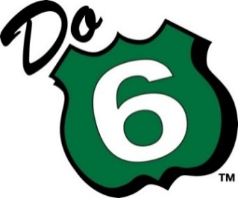 | PA Route 6 Façade Grant Program  in Lackawanna County  Official Application  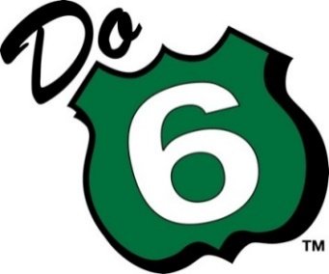 |  | 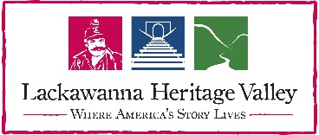
 | INSTRUCTIONS
ALL applicants must complete all sections of the Grant Application and submit all required supporting documents to be considered for funding. If additional space is required, please send as separate Word attachment, and reference the appropriate line item on this application. Applicants are encouraged to apply via email. Please send your official application form and proposals to:

PA Route 6 Alliance
% Vanessa Billings-Seiler, Façade Program Coordinator
11 West Main Street
PO Box 180, Galeton PA 16922
812-774-7082
facade@paroute6.com

Deadline: Applications must be postmarked/e-mailed no later than April 21, 2023, 4pm
Basic Information
1. Name of business
2. Type of establishment (restaurant, store, canoe livery, etc.):
3. Name of owner:
4. Years in operation:
5. Organizational structure: sole proprietorship, partnership, corporation or other (please specify)
Business address and Contact Information
6. Phone: |  | 7. Fax:
8. E-mail (required): |  | 9. Website:
10. Street:(please state if you are along Rt 6)
11. City:
12. County and Zip Code:
13. Name of main contact at establishment, if other than owner:
14. Address and phone of owner, if other than establishment address:

Project information
15. Is your establishment located in Lackawanna County? | Yes |  | No
16. Did you contact your local municipality to follow any local ordinances? If applicable, please provide supporting documentation. | Yes |  | No
17. Is your request for exterior building façade improvements only including storefronts, windows/doors, exterior restoration and/or architectural elements, awnings & canopies, signage, painting, and lighting? | Yes |  | No
18. Have you submitted proof of property ownership (copy of your deed), local taxes, and property insurance documentation (copy of up-to-date paid Insurance and Taxes statement) with the application? All property owners must be current on their State, County, School District, and local municipal taxes and insurance. | Yes |  | No
19. Are you spending AT LEAST one dollar of your own money for every dollar of grant money that the business receives? This is a “cash match”  requirement. | Yes |  | No
20. Does the project have the most communitywide impact by enhancing the community character and public spaces; achieving visible results that enhance the downtown’s image, marketability, and economic vitality? | Yes |  | No
21. Does the project restore, or enhance the historical and architectural features that define the building’s style and character; that thoughtfully consider the traditional architectural style types of the community? | Yes |  | No
22. Does the project reduce visual clutter, improve aesthetics, and contains elements that encourage pedestrian activity (sidewalks, trees/ landscaping /flower boxes, trails, lighting, benches, bike racks, and outdoor eating spaces)? | Yes |  | No
23. Does the project maintain and/or enhance the regions uniqueness; that capture the authenticity of the PA Route 6 Heritage Corridor and the Lackawanna Heritage area as opposed to copying the common “big box” type of design? | Yes |  | No
24. Does the project support making the town centers and community focal points and evoke a welcoming atmosphere? | Yes |  | No
25. Does the project support a larger community revitalization effort and/or leverage local private or public dollars in addition to the required grant match? | Yes |  | No
25.a. Please name plan or effort:
26. Have you applied or been awarded for façade grant funding in the past? If so, please explain: | Date: | Amount:
27. Does the project support creative design concepts and include use of local wood, stone, and glass materials for building accents? Vinyl, aluminum, or other synthetic siding materials are discouraged as primary façade materials in town centers. | Yes | No
28. Does the project restore and enhance the historical uniqueness of a traditional recessed entrance, where use of appropriate window/door sizes and patterns are consistent with community? | Yes | No
29. Does the project include facade signage that is reflective of community character using traditional materials such as wood and metal rather than plastic? Internally illuminated signage or flashing lighted signs are strongly discouraged. | Yes | No
31. Does the project emphasize door entries by using roofs, recessions, awnings, pilasters, or other details that express importance of the entrance and those that incorporate use of large glass paneled windows for displays of goods? | Yes | No
31. Does the project use a complementary color pallet for painted commercial facades? Earth tones and natural colors are encouraged while use of bold, bright, fluorescent, black, or metallic colors are discouraged. | Yes | No
32. Does the project incorporate use of historical markers, patriotic flags, and /or community themed banners? | Yes | No
33. Does the project lighting include minimum quantities necessary for pedestrian safety and security; focusing light downward only onto areas necessary? Are light fixtures consistent with architecture of the building? | Yes | No
34. Can the proposed improvement be implemented by Nov. 1st, 2023? | Yes | No
35. How much do you expect the façade improvement project to cost?
36. How did you arrive at this estimate?

37. Please include a sketch of the proposed façade improvement, along with any important details about its look and feel. Many companies/designers will offer such a sketch as a free service prior to signing a contract. If such a sketch is not available, please explain why and describe the proposed façade project in as much detail as possible. (Required)
38. In the space provided here, in a few sentences or a paragraph, please offer any additional comments that the selection committee should take into account as they consider this application:

39. How many employees (part-or-full time) does your business have:
40. Has your business experienced any job growth (part-or-full time positions) in the last two years? If so, please state how many:

41. Why are you embarking on improving the façade at your business?

42. Do you expect your new façade improvement to impact your business in a positive way? Please explain:

43. If you plan to use the PA Route 6 logo in some way, please describe that use here:

44. Explain how your establishment is helping to grow the region’s nature and heritage tourism industry.

44. Please include before pictures of your façade to show where the work will be constructed.

AGREEMENT
- This is a reimbursement grant. The applicant must pay for the full cost of the façade improvement and all related charges, then submit receipts and copies of cancelled checks to receive the agreed-upon award.
- The selection committee expects all available grant monies to be awarded to applicants. Any cost over-runs incurred by the applicant will be the applicant’s responsibility. If the façade improvement costs less than the original estimate, the grant will cover half the invoiced amount.
- All applications must be postmarked or submitted electronically by April 21, 2023, 4pm
- The selection committee intends to name grant recipients no later than June 1, 2023. At that time, the committee will contact all applicants about the status of their applications and distribute any additional materials as required.
- Applicants who win the award agree to submit final, professional drawings and/or schematics of their facade designs to the selection committee for final approval prior to authorizing fabrication and installation of the façade improvement, in order to ensure that the actual façade improvement complies, substantially, with the preliminary design submitted with the application materials. These drawings must be submitted by May 17, 2023.
- All projects must be completed by Nov. 1, 2023. Any projects that do not meet the deadline, for any reason, risk losing some or all of the award.
- Applicants must submit photos of the completed, installed façade improvement to receive the award.
- Applicants who win awards agree to allow the Pennsylvania Route 6 Alliance, Lackawanna Heritage Valley National and State Heritage Area, and affiliated state agencies to use photos and write-ups about their projects in press releases, stories, and any other promotional materials.
- By listing my name and contact information below, I affirm that all information in this application and all attachments are true and correct to the best of my ability, and that the receipt of any grant funds relative to this request will be used for the purposes detailed within this application.
In lieu of handwritten signature, I understand that my electronic submission is the same as my signature.
10. Applicants: I agree that if grant is approved, I will provide a full grant report and the necessary documentation including copies of receipts and / or proof of vendor payments provided by said grant by Nov. 1, 2023. I understand that until an approved report is accepted by The Pennsylvania Route 6 Alliance, I will not be eligible to receive the grant award. Applicants who submit the required materials after the deadline run the risk of forfeiting their grant award.

Name (Applicant):
Signature (electronic acceptable):
Date:
Signature of property owner if different than application:

Print name of property owner
Date:

