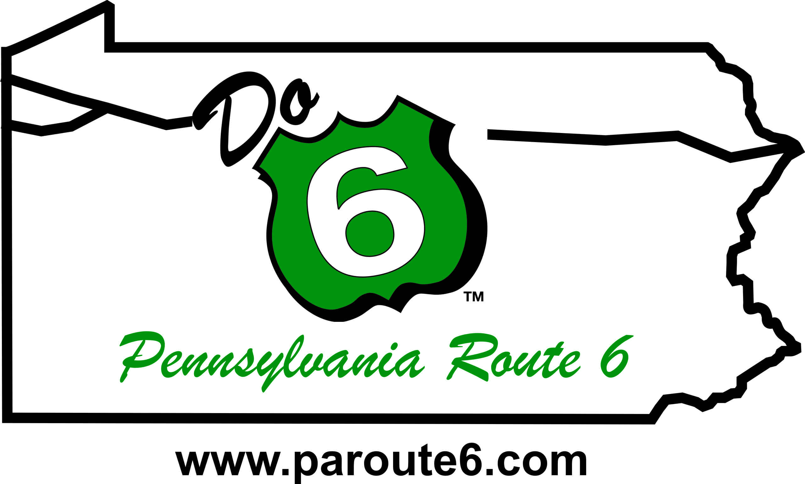**FOR IMMEDIATE RELEASE:**

October 16, 2024

**Candace Hillyard, Executive Director**

**PA Route 6 Alliance**

814-435-7706

[info@paroute6.com](mailto:info@paroute6.com)

**PA Route 6 Alliance Celebrates Accomplishments and “Do 6” Awards**

*Recognizing outstanding persons, groups, and communities along PA Route 6!*

October 16, 2024 — Community leaders, groups, business owners, county commissioners, and state legislators joined the PA Route 6 Alliance in Honesdale on October 10th-11th to participate in the organization’s 2024 Educational Workshop, Annual Meeting & “Do 6” Awards presentation.

During the Educational Workshop on Thursday, October 10th, participants learned how outdoor recreation can unite various communities, attract and retain residents, and engage community members. PA Humanities and Community Heart & Soul demonstrated their unique method of resident storytelling that leads to community engagement. During the panel discussion,representatives from the Lackawaxen River Trails, PA Humanities, Community Heart & Soul, Pocono Mountains Visitors Bureau, PA Council on the Arts, DCNR, and DCED answered questions relating on how communities are connected through outdoor recreation economies.

Following our morning session at 6th & River, we embarked on a Fall Foliage Excursion to enjoy the scenery and have lunch aboard the Stourbridge Line. Local historian Jeff Hiller provided insights into how the preservation of Honesdale’s locomotive heritage has contributed to the local economy. Attendees had free time to explore downtown Honesdale before joining local leaders for a walking tour to learn more about current projects happening in the area. The day ended with a fun networking reception at Runaway Train Brewery.

The Annual Meeting and “DO 6” Awards took place on Friday, October 11th at 6th & River. Nathan Reigner, Director of Outdoor Recreation at DCNR, our Keynote Speaker, addressed statewide initiatives aimed at unifying, growing, and strengthening Pennsylvania’s outdoor industry to bring about economic, health, and conservation benefits across the Commonwealth. PA Humanities and Community Heart & Soul presented the impact of Action Plans within a community, and how outdoor recreation fits into it. The Alliance delivered a summary of this year’s accomplishments and next year’s goals and recognized a select six outstanding individuals and groups during the annual “Do 6″ awards ceremony. These individuals, organizations, businesses, and corporations embody the mission of the PA Route 6 Alliance, which is to protect, preserve, and enhance the scenic, cultural, historical, and recreational resources of Pennsylvania’s northern tier.”

“DO 6” Awards were presented for 2024 in the categories of *Heritage Partnership*, *Heritage Tourism*, *Heritage Leadership, Artisan of the Year, Heritage Community of the Year, and Lifetime Achievement*.

The **Heritage Partnership Award** is given to a person, group, or project that has demonstrated excellence in historic and cultural preservation, interpretation, and/or education through cross-corridor thinking and interagency cooperation. **The 2024 Heritage Partnership Award was presented to the Fort LeBoeuf Historical Society, Erie County.**

The Fort LeBoeuf Historical Society’s campus, located in Waterford, includes four buildings and two sites. Their interpretive activities and collections focus on the area’s Native American history, French and Indian War era history, and heritage as a small rural community in south central Erie County. The society serves as the northern terminus of Washington’s Trail, which follows young George Washington’s journey through western PA during the winter of   
1753-1754. The trail spans the MD/PA border to Waterford, and it can be explored using Washington’s Trail markers, trail brochures, tours, and special events. The society is an organizational partner of Washington’s Trail, which is both an interpretive program and a tourism promotion tool. Development of their 18th Century Teaching Garden began in 2019 and expanded the interpretation and living history demonstrations offered through the Fort LeBoeuf Museum, such as the Colonial era blacksmith shop and creekside canoe carving. It includes 11 raised beds for herbs, vegetables, and flowers, an area for fruit trees, a potting shed, compost area, and a chair makers shop. The demonstration garden has been well-received by visitors, becoming a must-see space within the society’s campus. The society also gave birth to Waterford Heritage Days, the community’s largest annual celebration that hit 50 years in 2023.

The **Heritage Tourism Award** is presented to the organizers of a project or event that furthers economic and tourism development while still respecting the heritage and cultural resources of the corridor. **The 2024 Heritage Tourism Award was presented to Milford Hospitality Group, Pike County.**

Milford Hospitality Group has undertaken a huge amount of historical preservation efforts with Forest Hall, the Milford Theater, Hotel Fauchère, Tom Quick, Cliff Park among other properties. The Rosado family has worked hard to maintain historic Forest Hall as an event space, art gallery and retail shops on the first level. Nearby, the historic Hotel Fauchère has continued to operate with guests’ ability to stay on site, dine at the Delmonico Room or Bar Louis, and visit the nearby restored Milford Theater which has programming year-round for arts and culture. MHG has taken on Apple Valley operating the restaurant and the village of shops as well. The Rosado family has made it a priority to work with local organizations including Grey Towers to promote the heritage of the community and preserve it for visitors well into the future. Milford Hospitality Group restores their city’s landmark properties, encourages business-to-business growth, and is reestablishing Milford as a cultural destination, while protecting   
its historic culture and values.

The **Heritage Leadership Award** is presented to a person, business, or organization for meaningful contributions and/or partnerships that have resulted in the enrichment of our communities through landscape initiatives or historic preservation**. The 2024 Heritage Leadership Award was presented to Jane Varcoe, Wayne County.**

Jane Varcoe embodies the heritage work PA Route 6 Alliance. She has served over a decade on the PA Route 6 Alliance Board and is currently an Honorary Director. Jane has been on Waymart Borough Council for 50+ years and a leading force in obtaining grant funding for various historical preservation initiatives and many quality-of-life efforts. One of Jane’s great accomplishments was spearheading the Gravity Railroad Station including improvements such as a platform which made the Open-Air Gravity Rail Car accessible to visitors. Jane is dedicated and involved with the Waymart Area Historical Society and the D&H Gravity Railroad Depot. Her home is historic as well and is part of the aforementioned D&H Gravity Railroad.

The **Artisan of the Year Award** is presented to an Artisan Trail member that exemplifies the goals of the PA Route 6 Artisan Trail program with special attention to regional thinking and cooperation while promoting the arts along the corridor. **The 2024 Artisan of the Year Award was presented to Pop’s Culture Shoppe, Tioga County.**

Pop’s Culture Shoppe provides a space for community members of all ages to enjoy games both old and new. Anja and Julian Stam’s hospitality keeps guests coming back. They are active community members and host the annual Wellsboro Comic Con. Anja and Julian started the Wellsboro Comic Con in 2022 as a way to thank the community for supporting their store, Pop’s Culture Shoppe, through 10 years of business. The Comic Con has since drawn thousands of attendees to celebrate “Classic Comic Creativity Wrapped in Retro Rural Charm.” Though organized and sponsored by Pop’s, the Wellsboro Comic Con takes place across multiple indoor and outdoor venues, demonstrating a commitment to enhancing the cultural and economic prosperity of the town by drawing visitors to cultural institutions such as the Deane Center for the Performing Arts, the Gmeiner Art and Cultural Center, and the Arcadia Theatre, as well as local retailers, restaurants, and hotels. In 2024, the Wellsboro Comic Con eliminated ticket sales, becoming a completely free festival focused on a mission to bring top-tier comic creators to Wellsboro without limiting who has access to meet and learn from these artists. Guest creators have visited from New York, California, and Ontario, and presented on topics including storyboarding, publishing, and cartoon-making. Using “Classic Comic Creativity Wrapped in Retro Rural Charm,” the Wellsboro Comic Con enhances the natural, cultural, scenic, recreational, and historical resources that Wellsboro and the surrounding area have to offer.

The **Heritage Community of the Year Award** is presented to one designated Heritage Community that is embracing their Heritage Tourism WorkPlan and implementing worthwhile projects that show impact and results in their community. **The 2024 Heritage Community of the Year Award was presented to Kane, McKean County.**

Nestled in McKean County, Kane is a “Star in the Forest” community that has seamlessly blended its historic charm with a forward-thinking vision. From the preservation of its iconic landmarks and historic buildings to the celebration of its unique traditions and stories, Kane has worked tirelessly to maintain and share the cultural fabric that makes it so special. Kane has consistently demonstrated a deep commitment to honoring its past while fostering a vibrant and inclusive community spirit. Through collaborative efforts, including the revitalization of the historic downtown district, the promotion of local arts and crafts, and the hosting of educational programs including active transportation planning and updating their Heritage Community WorkPlan. The community has been awarded a competitive PA Council on the Arts Creative Communities Initiative to lead local artists and residents for creative place making   
projects and activities including public art, community festivals, and creative small businesses. They received the 2024 Trailblazing Community of the Year Award from Pennsylvania Environmental Council. Kane has ensured that its history and heritage is not only preserved but also actively lived and appreciated by both residents and visitors.

The **Lifetime Achievement Award** is presented to a person or agency who exemplifies outstanding leadership and advances the PA Route 6 Alliance mission through heritage development**. The 2024 Lifetime Achievement Award was presented to Jason Krise, Bradford County.**

Jason Krise’s remarkable service and enduring contributions to the PA Route 6 Alliance over the last 15 years has played an instrumental role in shaping the vision and continued success of the Alliance. Jason’s leadership on the PA Route 6 Executive Committee extends beyond strategic planning and governance; he has been a passionate advocate for the region, working to preserve its unique assets and ensure its future prosperity. Jason has consistently demonstrated a deep commitment to preserving the cultural, historical, and economic vitality of the communities along Route 6. His efforts have left an indelible mark on the PA Route 6 community, making him a true steward of this iconic corridor. This award honors Jason’s lifetime of service and dedication, celebrating his legacy as a leader, advocate, and champion of Route 6 and beyond. His leadership has not only preserved the past but also paved the way for a vibrant future.

Alliance Executive Director, Candace Hillyard states, "We are thrilled with the success of this year’s annual meeting in Honesdale, a town that exemplifies the heart and history of the PA Route 6 Corridor. The passion and dedication of our partners and community members continue to inspire us as we work together to promote and preserve the unique character of this historic route. Thanks to everyone's efforts, we are driving toward a brighter future while honoring the heritage that makes PA Route 6 truly special. We always look forward to these opportunities to share our organization’s accomplishments and celebrate the people and projects that help further our mission of supporting the PA Route 6 Heritage Corridor.”

For more detailed information on the “Do 6” Award recipients, visit our [website](https://paroute6.com/2024-educational-workshop-annual-meeting/) or contact the Alliance at [info@paroute6.com](mailto:info@paroute6.com) or 814-435-7706.

*The PA Route 6 Alliance, a 501(c3) corporation, was established in 2003 to manage the PA Route 6 Heritage Corridor and to implement branding and marketing plans, community development programs and other planning efforts along the corridor. The Alliance includes representatives from all 11 counties, 9 convention and visitor bureaus, 4 heritage areas, local development districts, local business owners, Chambers of Commerce, and other interested parties along the corridor. The PA Route 6 Heritage Communities program is a program of PA Route 6 Alliance and PA Route 6 Heritage Corridor funded by the PA Heritage Area Program under the Pennsylvania Department of Conservation and Natural Resources.* --End--